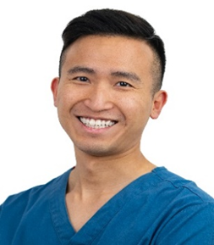

**Prof Manuel Wing Ho Man**

Specialty Doctor in Prosthodontics / Restorative Dentistry

Restorative Department, Associate Clinical Lecturer

Royal National ENT and Eastman Dental Hospitals

London, UK

**Navigating Challenges: Restorative Management of Suboptimal Positioning of Dental Implants**

Implants placed in areas of compromised bone can be challenging for a dentist to place and even more so to restore. Poor positioning of implants, whether it be due to anatomical restrictions or misjudged implant placement, can severely limit function, aesthetics and longevity if not addressed properly.

This presentation will offer an overview of the importance of prosthetically-guided implant placement.  It will explore the ramifications of implant positioning on restorative results and delve into the identification of implants situated suboptimally, along with the associated challenges in restorations. It will provide insights into various management approaches for rectifying suboptimal implant placement, alongside an appraisal of their respective limitations, illustrated through case studies.