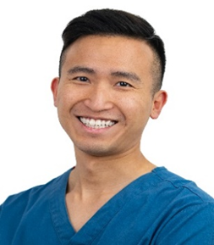

**Prof Manuel Wing Ho Man**

Specialty Doctor in Prosthodontics / Restorative Dentistry

Restorative Department, Associate Clinical Lecturer

Royal National ENT and Eastman Dental Hospitals

London, UK

Dr Manuel Man is a lecturer at UCL Eastman Dental Institute, involved in the MSc Restorative Dental Practice programme. Having moved from Hong Kong to pursue his passion, he enjoys working on complex restorative cases as a Specialty Doctor in Eastman Dental Hospital and a Restorative Dentist in a Specialist practice in London.

His passion and expertise revolve around restorative and implant dentistry, The training has equipped him to manage complex cases such as toothwear, tooth loss, implant prosthetic and hardware complications. He is recognised for his meticulous attention to detail and effective patient communication, which fosters a sense of assurance and comfort among patients during their treatments. His vision is to provide dental restorations that blend aesthetics and function, all while adhering to a conservative and minimally-invasive approach, with a keen focus on preserving the beauty provided by nature. He presents at national and international organisations including BDA, ITI, EPA and HKDA.