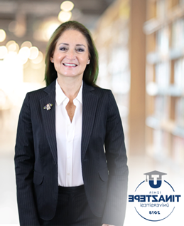

**Prof. Ebru Karabece Çal**

Chair of Prosthodontics Department Faculty of Dentistry

Tinaztepe University, Izmir, Turkey

Prof. Dr. Ebru Karabece Cal entered Ege University School of Dentistry in 1986 and graduated in 1991. She started working as a research and teaching assistant in the Department of Prosthodontics in the same faculty. Worked as a clinical-observer and researcher in Mayo Clinic, USA, during her residency in 1997. In 1998 she accomplished her doctorate degree with the thesis “Evaluation of microbiologic adherence and hardness changes of four different resilient denture-lining materials.” Dr. Karabece Cal became an Associate Professor in 2006, and Professor in 2011 in the Department of Prosthodontics, Ege University School of Dentistry. She started working in Tinaztepe University Faculty of Dentistry as the chair of Prosthodontics Department in November 2021 where she took part as one of the cofounders of the Dental Faculty.

She has more than 50 articles, which were published in national and international journals, and has many lectures and presentations in various key congresses and meetings.

Dr. Karabece Cal is an active member of ICP, EPA, IADR and TPID and is a reviewer of various national and international journals. Her primary research areas are Implantology, Adhesive Dentistry, Esthetics and Geriatrics.