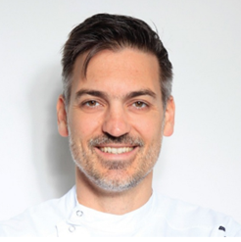

**Prof Nikola Petricevic, DDM, MS, PhD**

Associate Professor, Prosthodontics Department,

School of Dental Medicine

University of Zagreb, Croatia

Dr. Nikola Petricevic graduated from the University of Zagreb, Faculty of Dental Medicine, in 2002. He completed a prosthodontic residency and defended the Ph.D. thesis in 2009. He continued with a one-year ITI fellowship at Dental Clinic George Eastman (Rome, Italy) in 2011. He was awarded with the Rector's Award for scientific student research work in 2001. He is an active participant in international and domestic congresses, where he has been awarded twice for an oral lecture.Since 2004, he has been working at the Department of Removable Prosthodontics at the Faculty of Dental Medicine as a researcher. His main activities and responsibilities are teaching and lecturing undergraduate dental students in prosthodontics and implantology, occlusion and temporomandibular disorders. He was a supervisor to students on many graduate theses, as well as at two Ph.D. theses. He wrote more than 35 scientific articles and several book chapters, with 505 citations and H-index 13. His research interests are implant placement and prosthodontic suprastructures as well as dental patient-reported outcome measures. He is a peer-reviewer for 6 international dental journals and Editorial Board Member in two journals. He is a member of scientific and professional societies. He speaks English and Italian language.